**User Guide Aplikasi PSMR**

# Tentang Aplikasi

# Menu Aplikasi

## 2.1 Superadmin

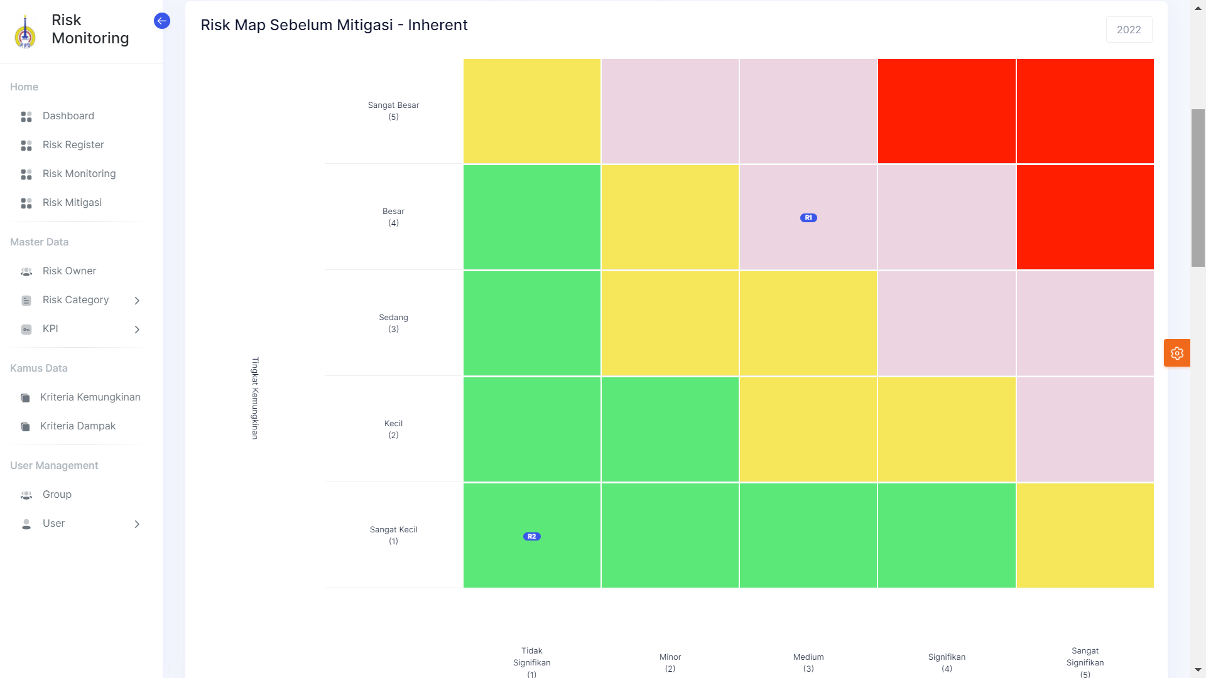

* 1. Dashboard
  2. Risk Register
  3. Risk Monitoring
  4. Risk Mitigasi
  5. Master Data

1. Risk Owner
2. Risk Category
3. KPI
   1. Kamus Data
4. Kriteria Kemungkinan
5. Kriteria Dampak
   1. User Management

## 2.2 Risk Owner

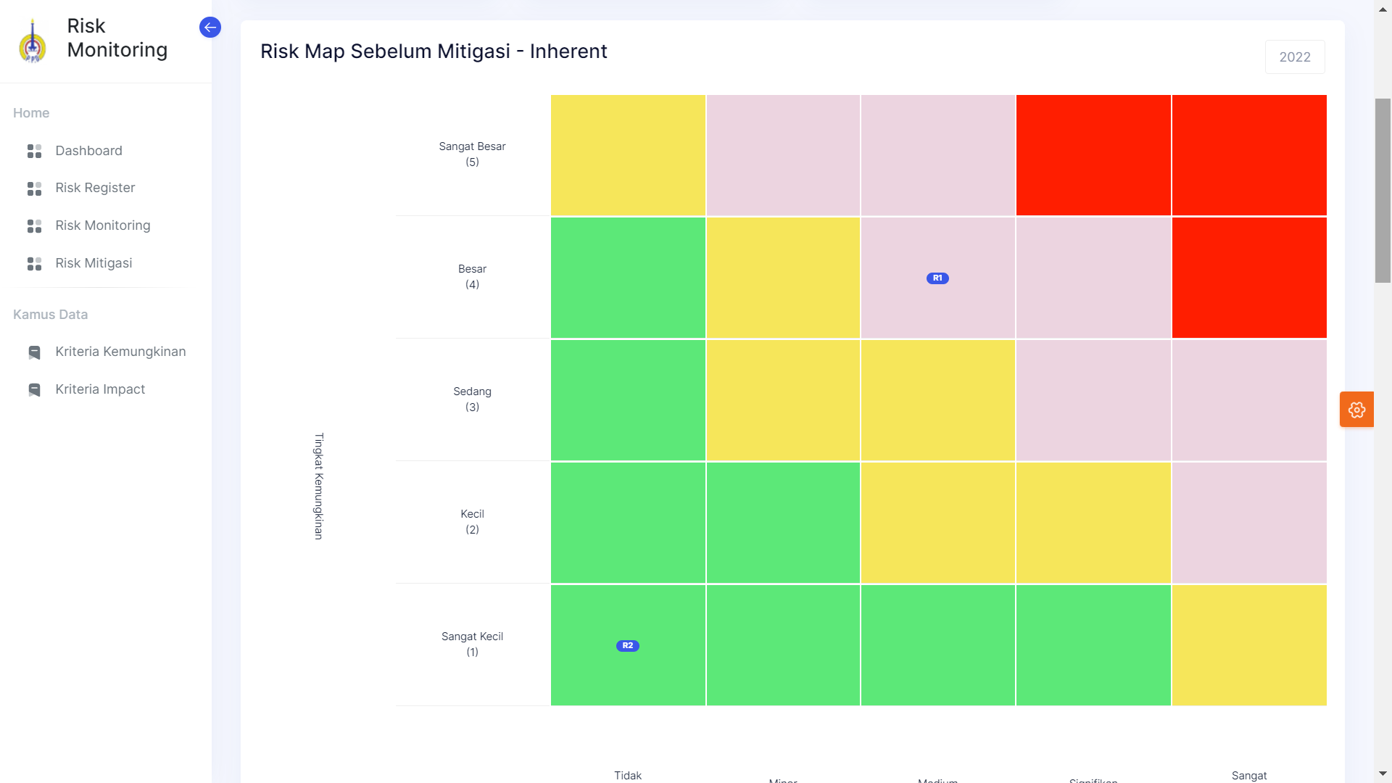

* 1. Dashboard
  2. Risk Register
  3. Risk Monitoring
  4. Risk Mitigasi
  5. Kamus Data

1. Kriteria Kemungkinan
2. Kriteria Dampak

# Panduan Pengguna - Superadmin

1. Login

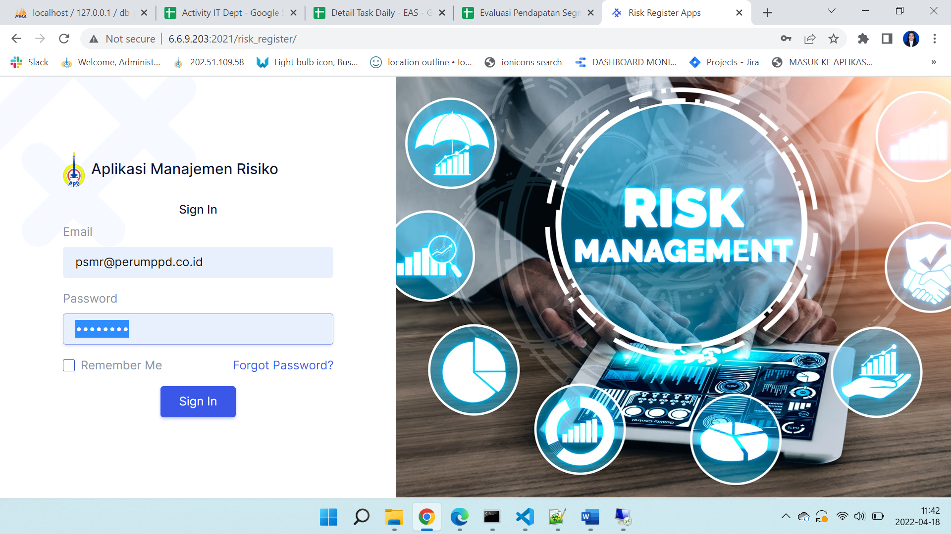

1. Dashboard

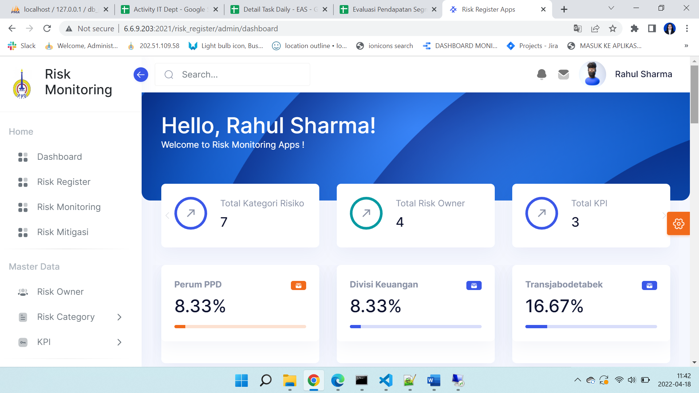

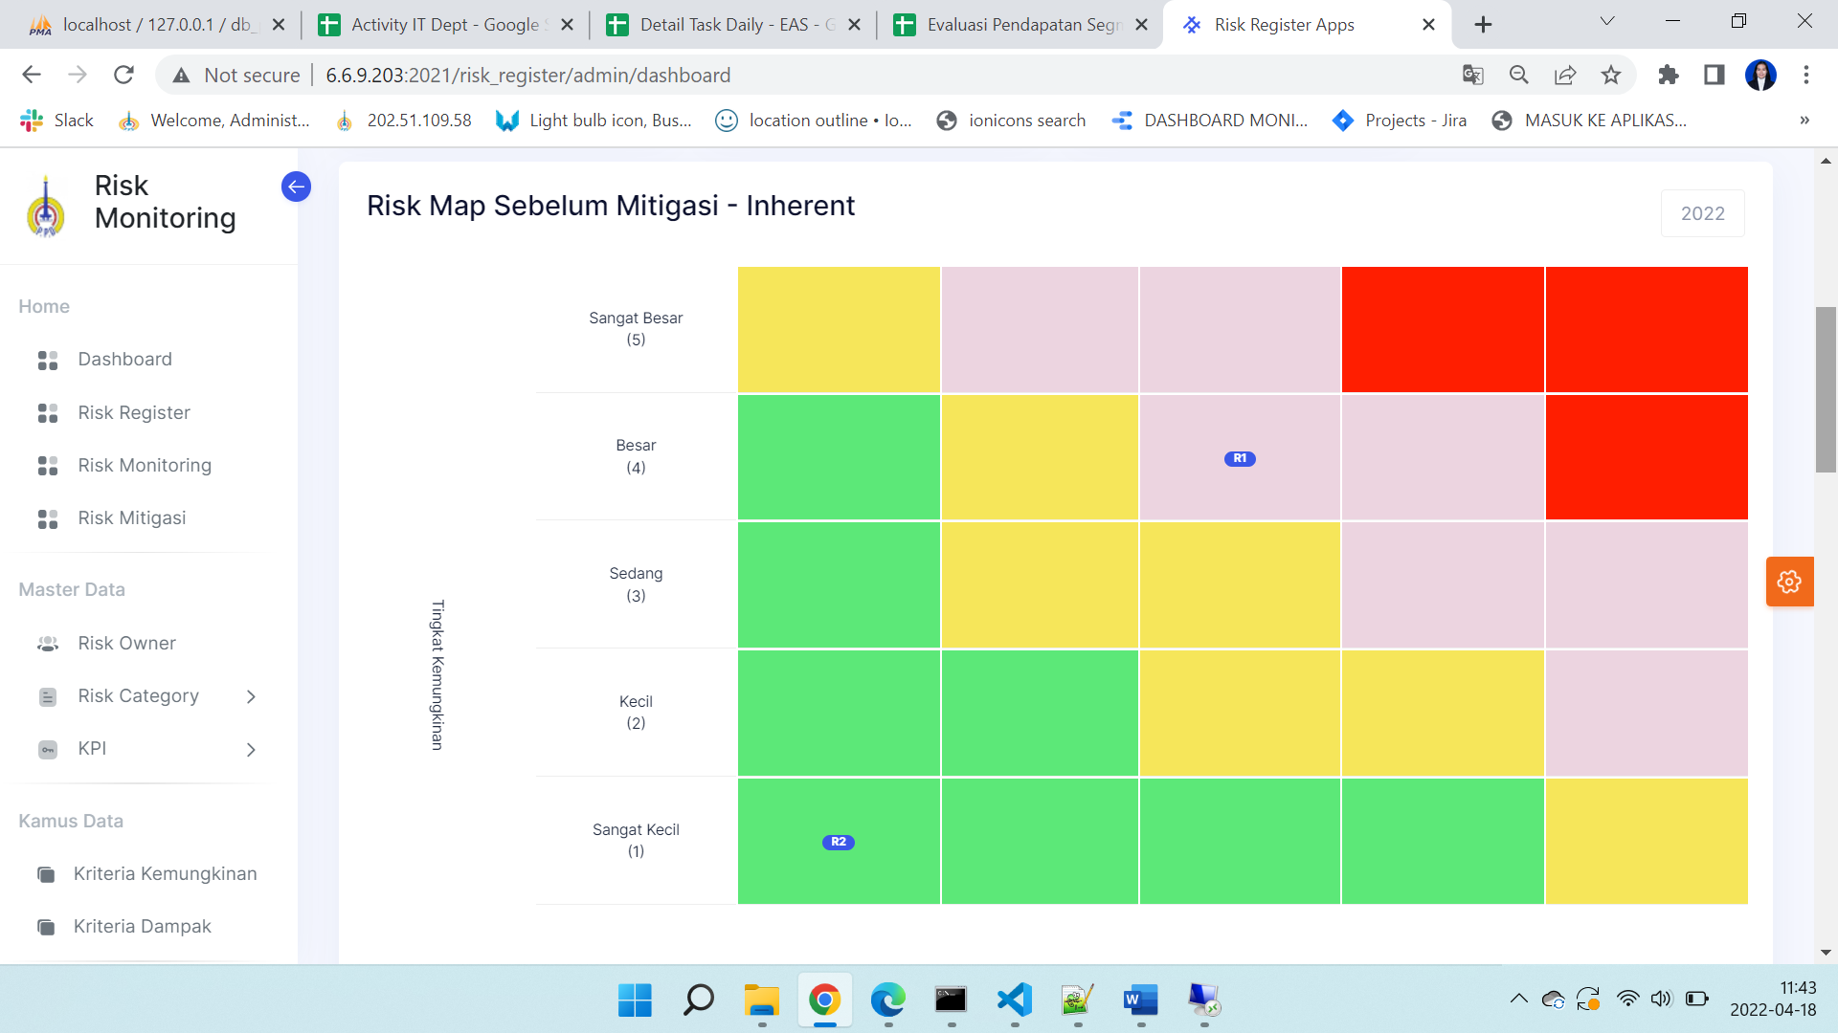

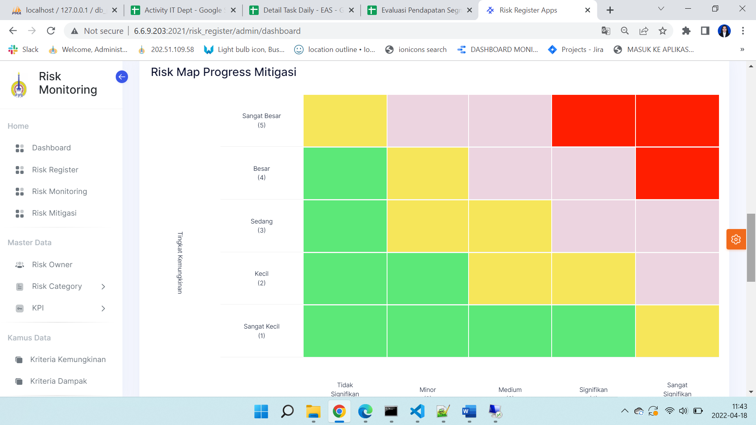

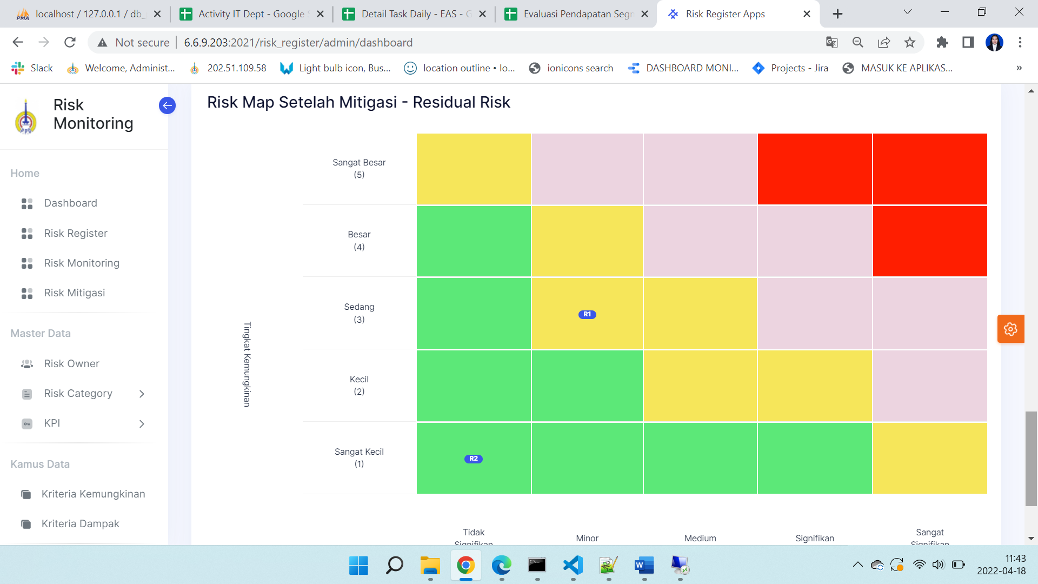

1. Risk Register

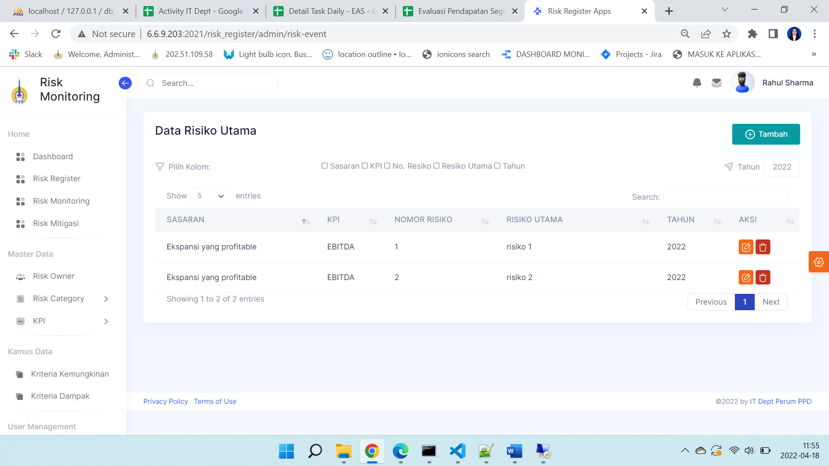

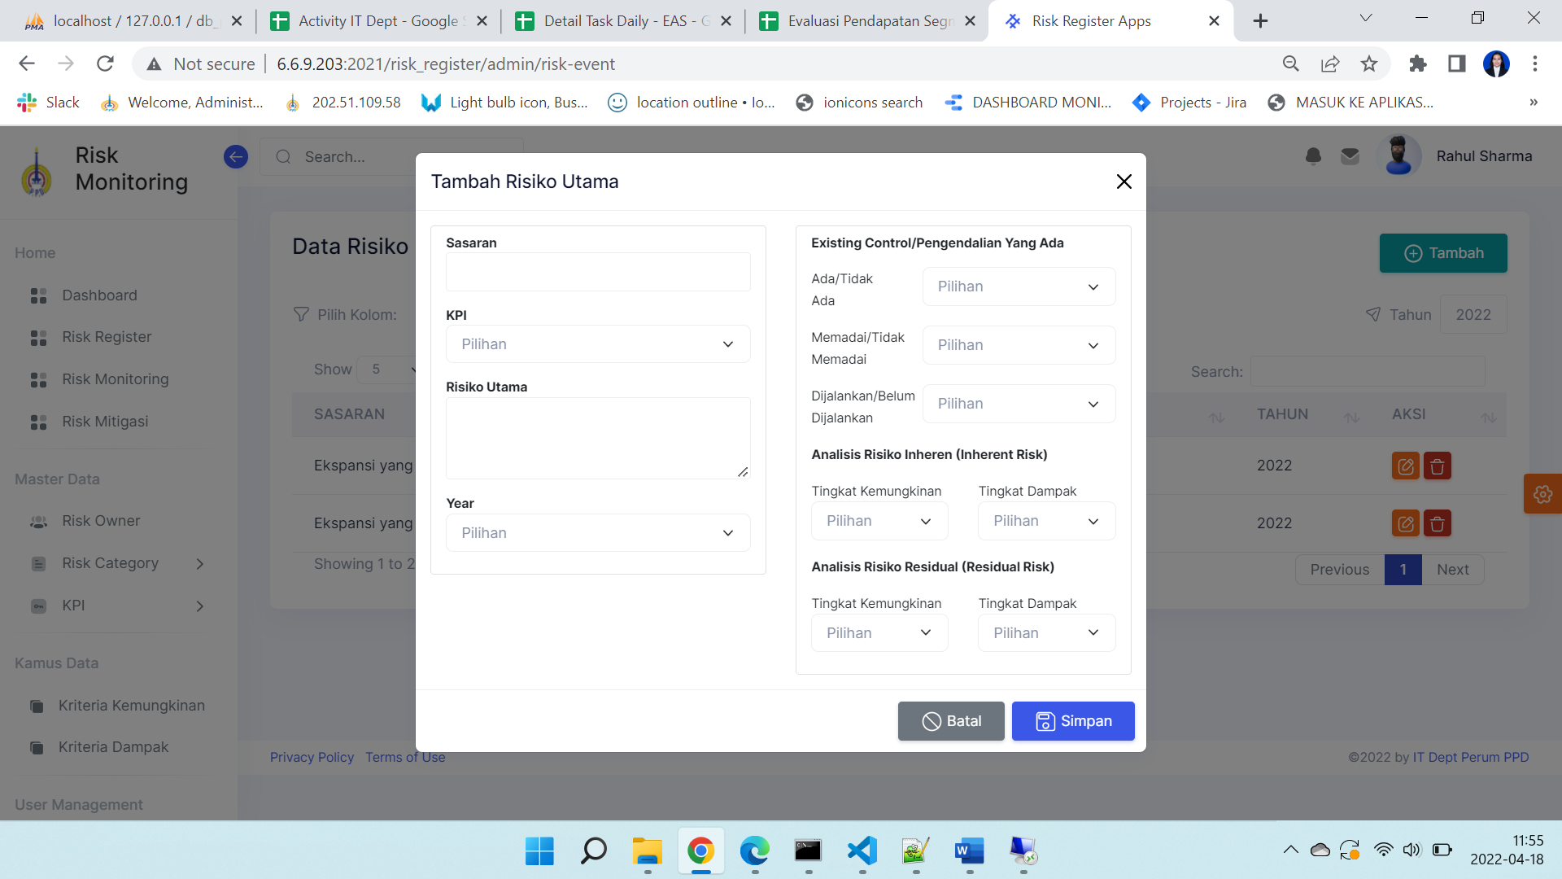

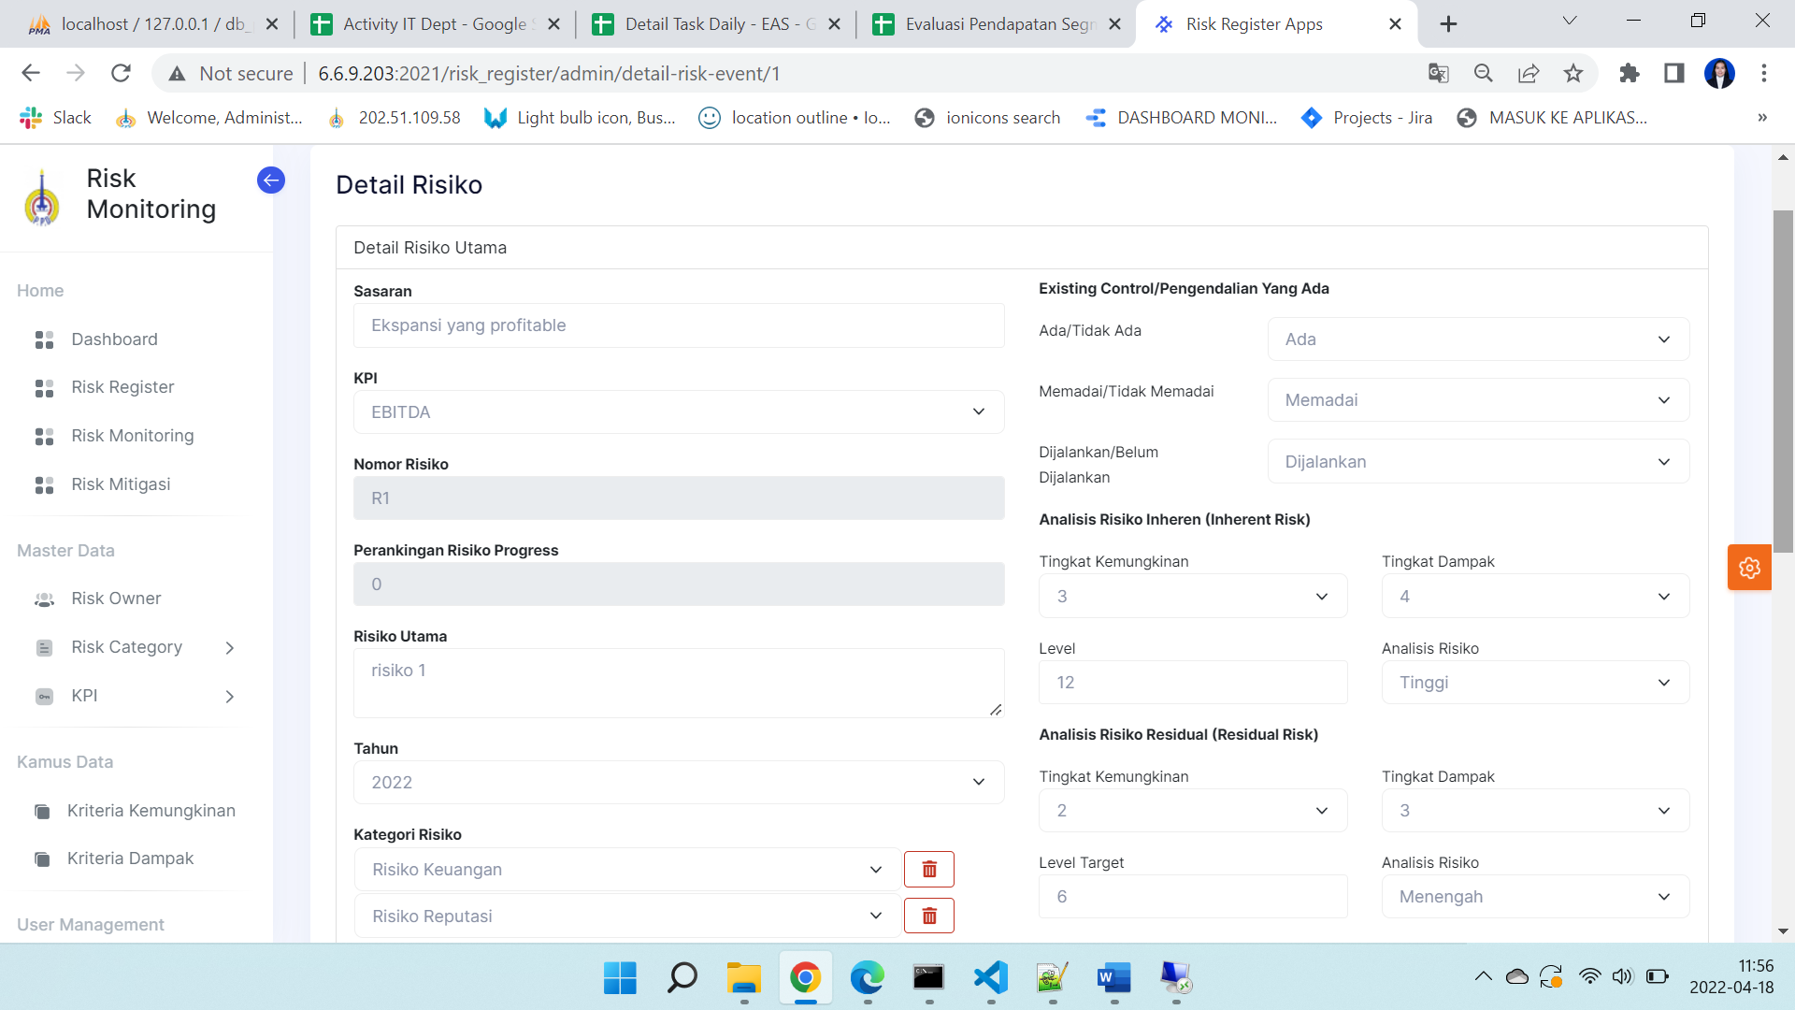

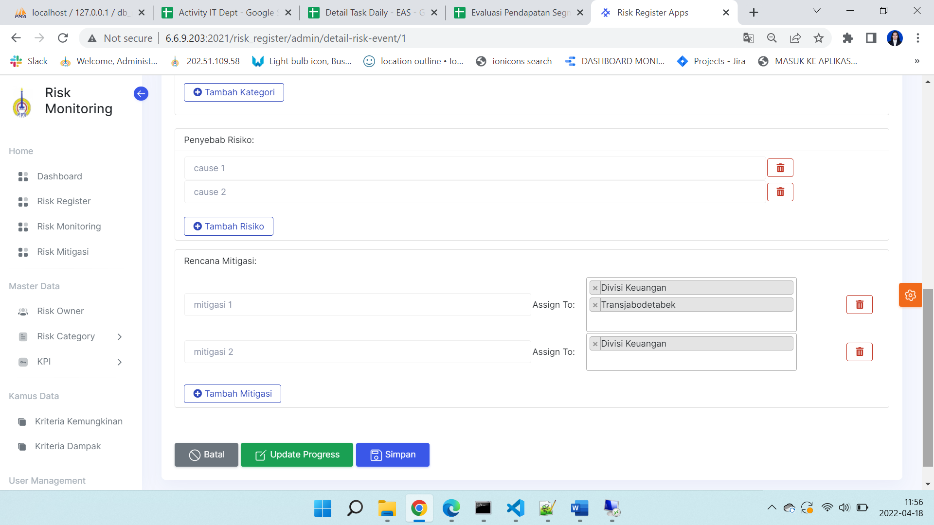

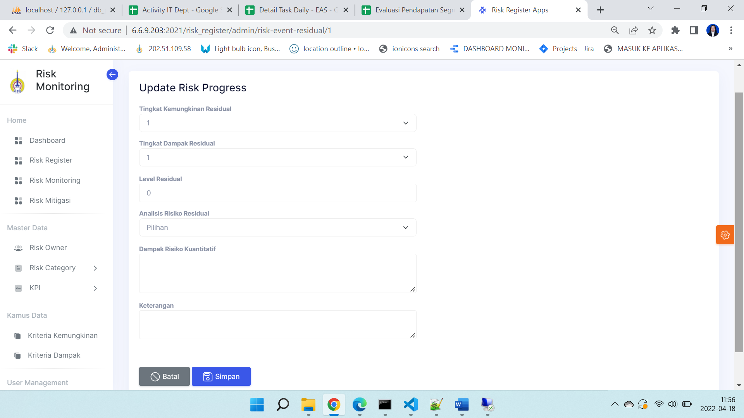

1. Risk Monitoring

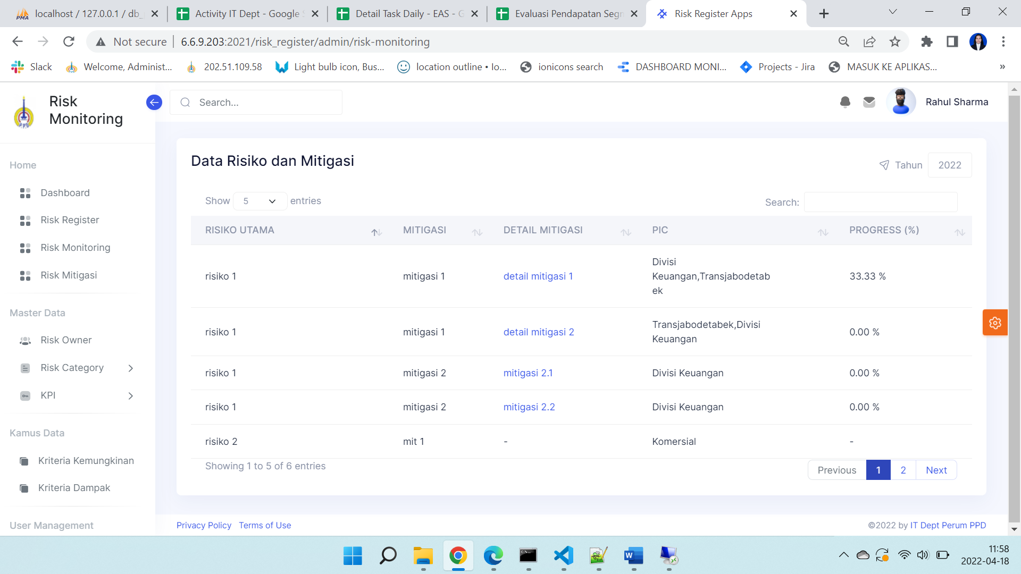

1. Risk Mitigasi

